EL NIÑO/SOUTHERN OSCILLATION (ENSO) DIAGNOSTIC DISCUSSION

issued by

CLIMATE PREDICTION CENTER/NCEP/NWS

13 March 2025

ENSO Alert System Status: La Niña Advisory

Synopsis: ENSO-neutral is favored to develop in the next month and persist through the Northern Hemisphere summer (62% chance in June-August 2025).

During February 2025, below-average sea surface temperatures (SSTs) weakened in the central and east-central equatorial Pacific Ocean (Fig. 1). All weekly Niño indices reflected this decline, with near-to-below average values lingering in the Niño-3.4 and Niño-4 regions (Fig. 2). Significant coastal warming was evident near South America, with the latest Niño-1+2 value at 1.6°C. This warming, however, was shallow (in the upper 50m) and was associated with low-level westerly wind anomalies over the eastern Pacific. Below-average subsurface temperatures also weakened (Fig. 3), but negative anomalies persisted at depth in the eastern Pacific and extended down to 200m in the central Pacific (Fig. 4). Tropical Pacific atmospheric anomalies continued to indicate La Niña conditions. Low-level wind anomalies remained easterly over the western and central Pacific, while upper-level wind anomalies were westerly over the east-central Pacific. Convection was suppressed around the Date Line and was enhanced near Indonesia (Fig. 5). The traditional and equatorial Southern Oscillation indices were positive. Collectively, the coupled ocean-atmosphere system reflected weakening La Niña conditions and a trend toward ENSO-neutral.
The IRI and North American multi-model ensemble predicts a transition to ENSO-neutral in the coming season (Fig. 6). The forecast team concurs and predicts ENSO-neutral, with chances greater than 50% through July-September 2025. As is typical for forecasts made in the spring, there is large forecast uncertainty at longer time horizons, with no outcome exceeding a 50% chance (chances of El Niño are the lowest). In summary, ENSO-neutral is favored to develop in the next month and persist through the Northern Hemisphere summer (62% chance in June-August 2025; Fig. 7).
This discussion is a consolidated effort of the National Oceanic and Atmospheric Administration (NOAA), NOAA’s National Weather Service, and their funded institutions. Oceanic and atmospheric conditions are updated weekly on the Climate Prediction Center website (El Niño/La Niña Current Conditions and Expert Discussions). Additional perspectives and analyses are also available in an ENSO blog. A probabilistic strength forecast is available here. The next ENSO Diagnostics Discussion is scheduled for 10 April 2025. To receive an e-mail notification when the monthly ENSO Diagnostic Discussions are released, please send an e-mail message to: ncep.list.enso-update@noaa.gov.

Climate Prediction Center
National Centers for Environmental Prediction
NOAA/National Weather Service
College Park, MD 20740

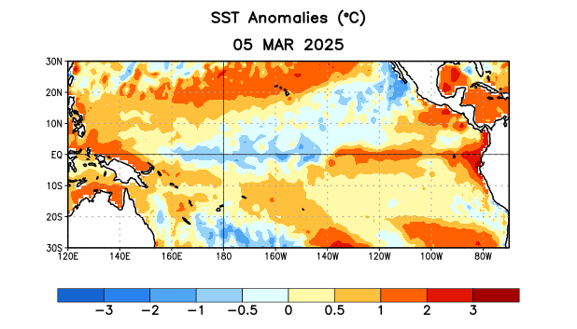
Figure 1. Average sea surface temperature (SST) anomalies (°C) for the week centered on 5 March 2025. Anomalies are computed with respect to the 1991-2020 base period weekly means.

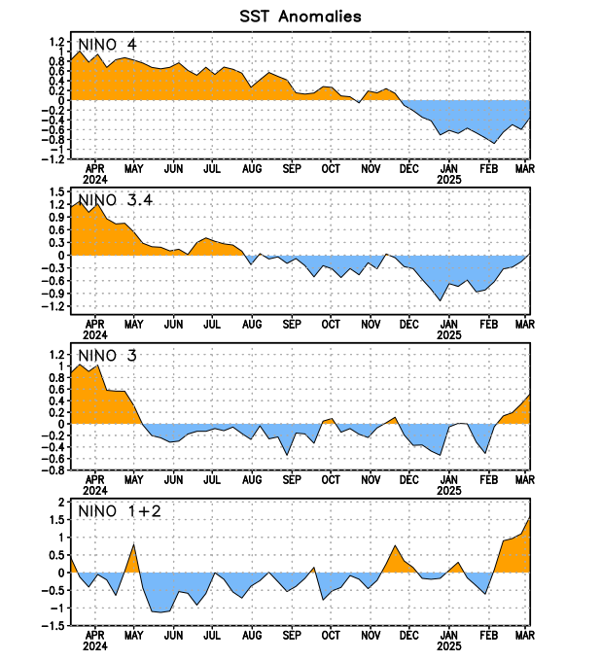
Figure 2. Time series of area-averaged sea surface temperature (SST) anomalies (°C) in the Niño regions [Niño-1+2 (0°-10°S, 90°W-80°W), Niño-3 (5°N-5°S, 150°W-90°W), Niño-3.4 (5°N-5°S, 170°W-120°W), Niño-4 (5ºN-5ºS, 150ºW-160ºE)]. SST anomalies are departures from the 1991-2020 base period weekly means.

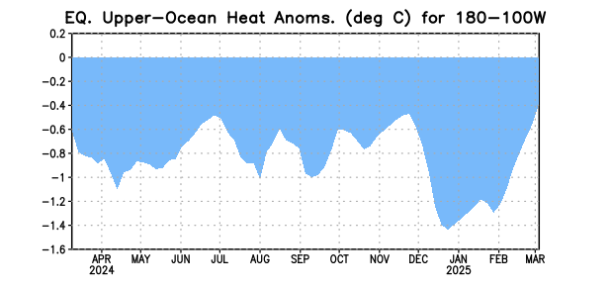
Figure 3. Area-averaged upper-ocean heat content anomaly (°C) in the equatorial Pacific (5°N-5°S, 180º-100ºW). The heat content anomaly is computed as the departure from the 1991-2020 base period pentad means.

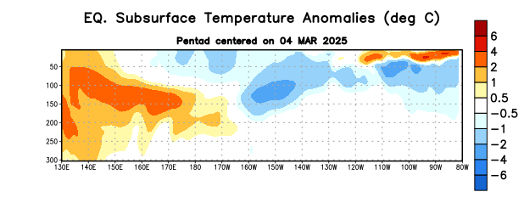
Figure 4. Depth-longitude section of equatorial Pacific upper-ocean (0-300m) temperature anomalies (°C) centered on the pentad of 4 March 2025. Anomalies are departures from the 1991-2020 base period pentad means.

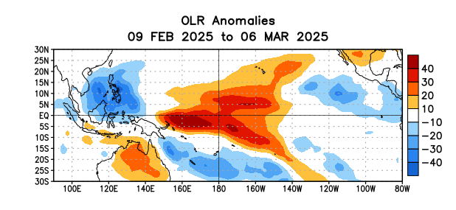
Figure 5. Average outgoing longwave radiation (OLR) anomalies (W/m²) for the period 9 February – 6 March 2025. OLR anomalies are computed as departures from the 1991-2020 base period pentad means.
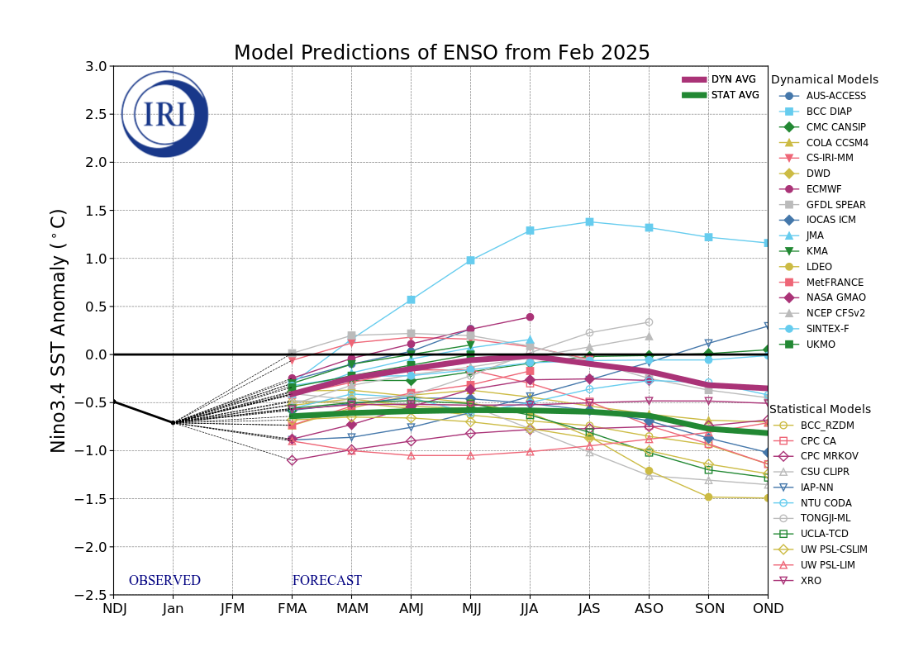
Figure 6. Forecasts of sea surface temperature (SST) anomalies for the Niño 3.4 region (5°N-5°S, 120°W-170°W). Figure updated 19 February 2025 by the International Research Institute (IRI) for Climate and Society.
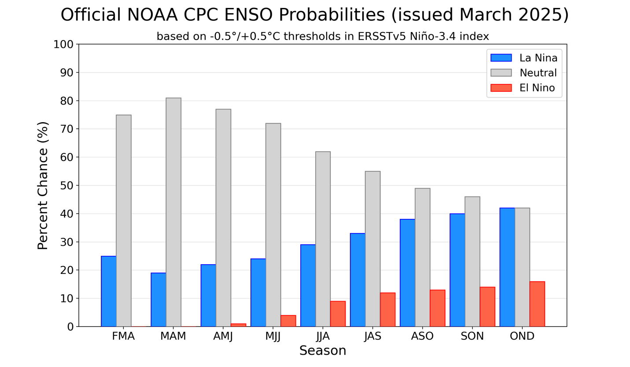
Figure 7. Official ENSO probabilities for the Niño 3.4 sea surface temperature index (5°N-5°S, 120°W-170°W). Figure updated 13 March 2025.

