EL NIÑO/SOUTHERN OSCILLATION (ENSO) DIAGNOSTIC DISCUSSION

issued by

CLIMATE PREDICTION CENTER/NCEP/NWS

9 January 2025

ENSO Alert System Status: La Niña Advisory

Synopsis: La Niña conditions are present and are expected to persist through February-April 2025 (59% chance), with a transition to ENSO-neutral likely during March-May 2025 (60% chance).

La Niña conditions emerged in December 2024 and were reflected in below-average sea surface temperatures (SSTs) across the central and east-central equatorial Pacific Ocean (Fig. 1). The latest weekly indices were -0.7°C in Niño-3.4 and -0.6°C in Niño-4, with values close to zero in Niño-1+2 and Niño-3 (Fig. 2). Subsurface cooling in the equatorial Pacific Ocean strengthened significantly (Fig. 3), with below-average temperatures dominating the central and eastern equatorial Pacific Ocean (Fig. 4). Low-level wind anomalies were easterly over the western and central Pacific, while upper-level wind anomalies were westerly over the central and eastern Pacific. Convection was suppressed over the Date Line and was enhanced over Indonesia (Fig. 5). The traditional and equatorial Southern Oscillation indices were positive. Collectively, the coupled ocean-atmosphere system indicated La Niña conditions.
The dynamical models in the IRI plume continue to predict a weak La Niña during the winter seasons, as indicated by the Niño-3.4 index values less than -0.5°C (Fig. 6). The North American Multi-Model Ensemble (NMME) predicts slightly cooler SST anomalies with La Niña persisting through February-April 2025. The forecast team favors the NMME guidance, predicting weak La Niña conditions through the early spring before transitioning to ENSO-neutral. Weak La Niña conditions are less likely to result in conventional winter/spring impacts, though predictable signals can still influence the forecast guidance (e.g., CPC's seasonal outlooks). In summary, La Niña conditions are present and are expected to persist through February-April 2025 (59% chance), with a transition to ENSO-neutral likely during March-May 2025 (60% chance; Fig. 7).
This discussion is a consolidated effort of the National Oceanic and Atmospheric Administration (NOAA), NOAA’s National Weather Service, and their funded institutions. Oceanic and atmospheric conditions are updated weekly on the Climate Prediction Center website (El Niño/La Niña Current Conditions and Expert Discussions). Additional perspectives and analyses are also available in an ENSO blog. A probabilistic strength forecast is available here. The next ENSO Diagnostics Discussion is scheduled for 13 February 2025. To receive an e-mail notification when the monthly ENSO Diagnostic Discussions are released, please send an e-mail message to: ncep.list.enso-update@noaa.gov.

Climate Prediction Center
National Centers for Environmental Prediction
NOAA/National Weather Service
College Park, MD 20740

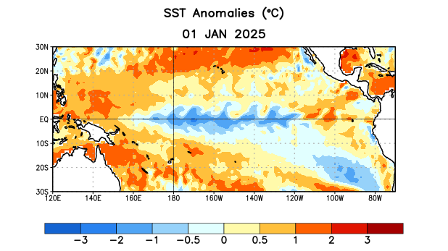
Figure 1. Average sea surface temperature (SST) anomalies (°C) for the week centered on 1 January 2025. Anomalies are computed with respect to the 1991-2020 base period weekly means.

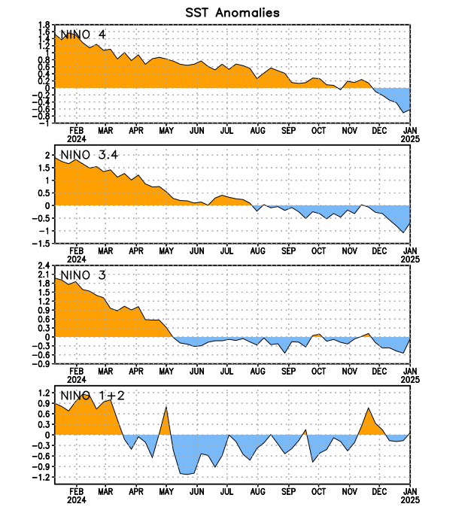
Figure 2. Time series of area-averaged sea surface temperature (SST) anomalies (°C) in the Niño regions [Niño-1+2 (0°-10°S, 90°W-80°W), Niño-3 (5°N-5°S, 150°W-90°W), Niño-3.4 (5°N-5°S, 170°W-120°W), Niño-4 (5ºN-5ºS, 150ºW-160ºE)]. SST anomalies are departures from the 1991-2020 base period weekly means.

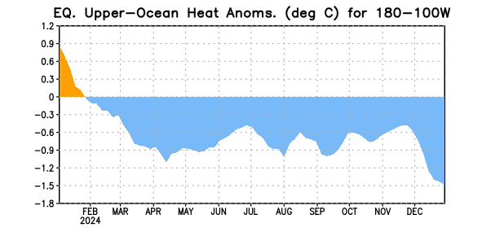
Figure 3. Area-averaged upper-ocean heat content anomaly (°C) in the equatorial Pacific (5°N-5°S, 180º-100ºW). The heat content anomaly is computed as the departure from the 1991-2020 base period pentad means.

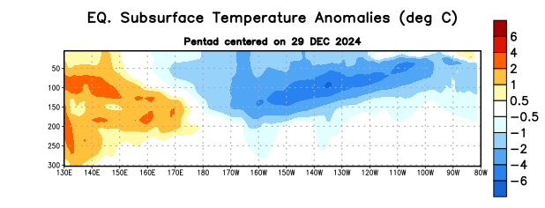
Figure 4. Depth-longitude section of equatorial Pacific upper-ocean (0-300m) temperature anomalies (°C) centered on the pentad of 29 December 2024. Anomalies are departures from the 1991-2020 base period pentad means.

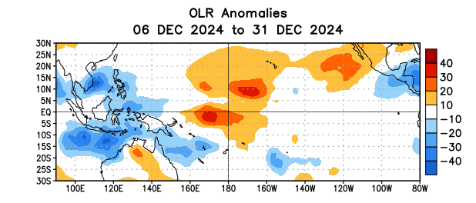
Figure 5. Average outgoing longwave radiation (OLR) anomalies (W/m²) for the period 6– 31 December 2024. OLR anomalies are computed as departures from the 1991-2020 base period pentad means.
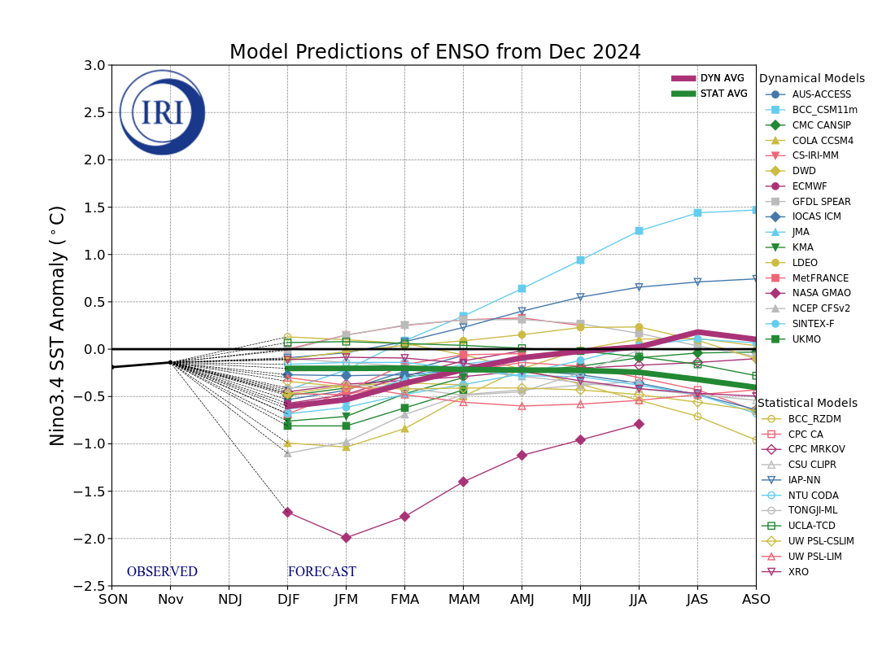
Figure 6. Forecasts of sea surface temperature (SST) anomalies for the Niño 3.4 region (5°N-5°S, 120°W-170°W). Figure updated 19 December 2024 by the International Research Institute (IRI) for Climate and Society.

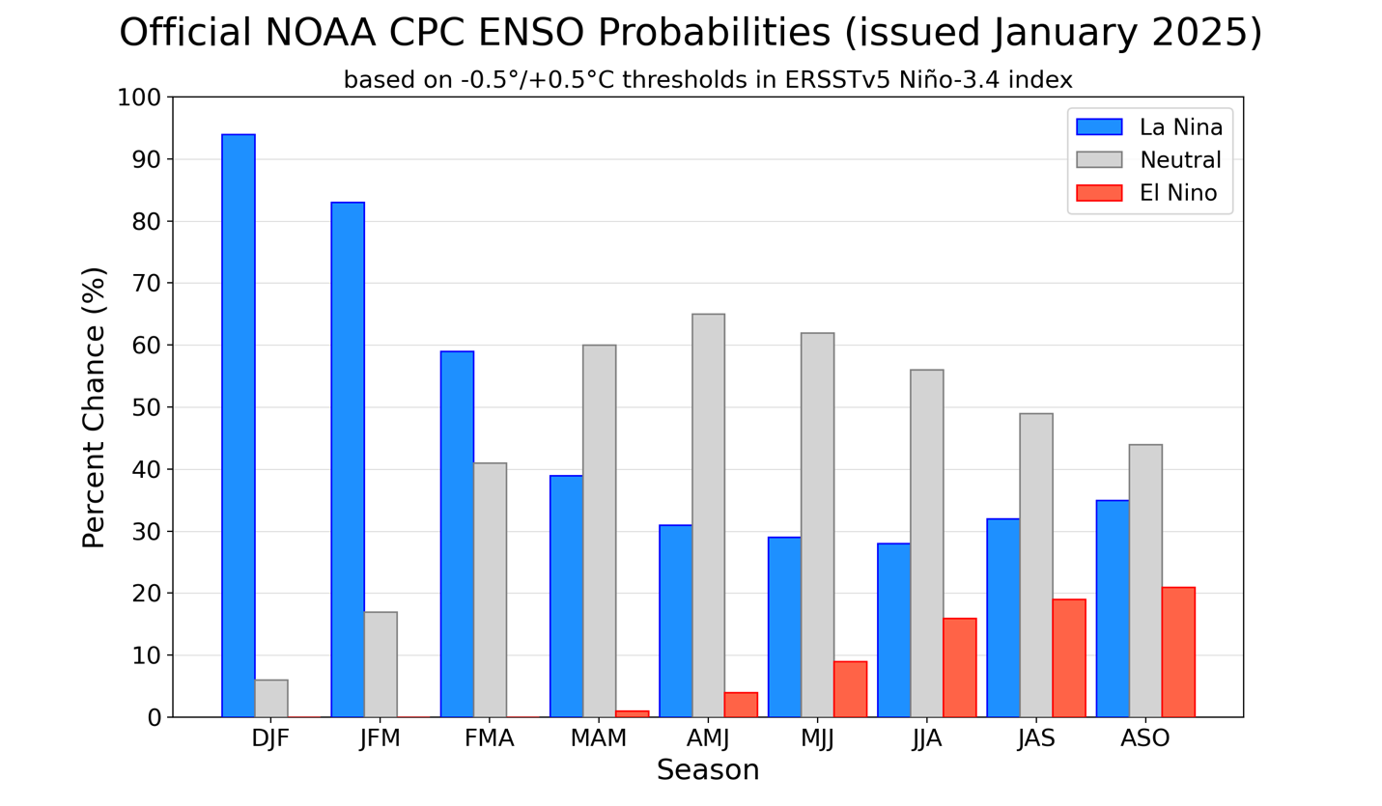
Figure 7. Official ENSO probabilities for the Niño 3.4 sea surface temperature index (5°N-5°S, 120°W-170°W). Figure updated 9 January 2025.

