EL NIÑO/SOUTHERN OSCILLATION (ENSO) DIAGNOSTIC DISCUSSION

issued by

CLIMATE PREDICTION CENTER/NCEP/NWS

13 February 2025

ENSO Alert System Status: La Niña Advisory

Synopsis: La Niña conditions are expected to persist in the near-term, with a transition to ENSO-neutral likely during March-May 2025 (66% chance).

La Niña conditions continued this past month, as indicated by the below-average sea surface temperatures (SSTs) across the central and east-central equatorial Pacific Ocean (Fig. 1). The latest weekly indices were -0.6°C in Niño-3.4 and -0.9°C in Niño-4, with values close to zero in Niño-1+2 and Niño-3 (Fig. 2). Below-average subsurface temperatures persisted (Fig. 3), with below-average temperatures dominating the central and eastern equatorial Pacific Ocean (Fig. 4). Low-level wind anomalies remained easterly over the western and central Pacific, while upper-level wind anomalies were westerly over the central Pacific. Convection was suppressed over the Date Line and western Pacific and was enhanced over Indonesia (Fig. 5). The traditional and equatorial Southern Oscillation indices were positive. Collectively, the coupled ocean-atmosphere system indicated La Niña conditions.
The IRI multi-model average predicts weak La Niña conditions to continue through February-April 2025 and then transition to ENSO-neutral (Fig. 6). The IRI dynamical model average and several of the models from the North American Multi-Model Ensemble (NMME) predict an earlier transition to ENSO-neutral in January-March 2025. The forecast team favors a weak La Niña through February-April, but there is also a 41% chance of ENSO-neutral emerging in this season. A weak La Niña is less likely to result in conventional winter/spring impacts, though predictable signals can still influence the forecast guidance (e.g., CPC's seasonal outlooks). In summary, La Niña conditions are expected to persist in the near-term, with a transition to ENSO-neutral likely during March-May 2025 (66% chance; Fig. 7).
This discussion is a consolidated effort of the National Oceanic and Atmospheric Administration (NOAA), NOAA’s National Weather Service, and their funded institutions. Oceanic and atmospheric conditions are updated weekly on the Climate Prediction Center website (El Niño/La Niña Current Conditions and Expert Discussions). Additional perspectives and analyses are also available in an ENSO blog. A probabilistic strength forecast is available here. The next ENSO Diagnostics Discussion is scheduled for 13 March 2025. To receive an e-mail notification when the monthly ENSO Diagnostic Discussions are released, please send an e-mail message to: ncep.list.enso-update@noaa.gov.

Climate Prediction Center
National Centers for Environmental Prediction
NOAA/National Weather Service
College Park, MD 20740

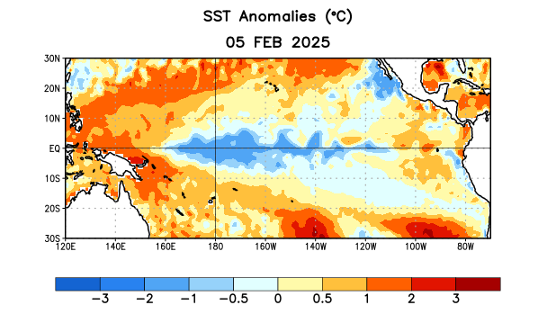
Figure 1. Average sea surface temperature (SST) anomalies (°C) for the week centered on 5 February 2025. Anomalies are computed with respect to the 1991-2020 base period weekly means.

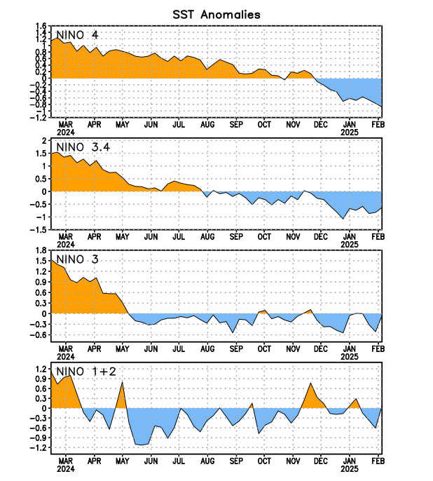
Figure 2. Time series of area-averaged sea surface temperature (SST) anomalies (°C) in the Niño regions [Niño-1+2 (0°-10°S, 90°W-80°W), Niño-3 (5°N-5°S, 150°W-90°W), Niño-3.4 (5°N-5°S, 170°W-120°W), Niño-4 (5ºN-5ºS, 150ºW-160ºE)]. SST anomalies are departures from the 1991-2020 base period weekly means.

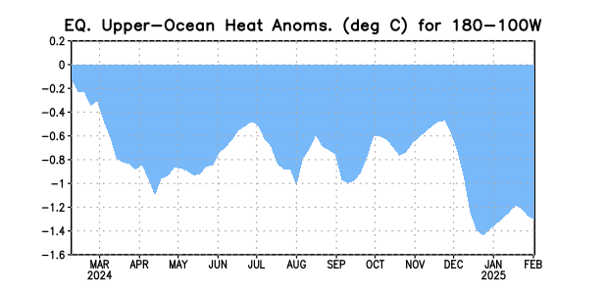
Figure 3. Area-averaged upper-ocean heat content anomaly (°C) in the equatorial Pacific (5°N-5°S, 180º-100ºW). The heat content anomaly is computed as the departure from the 1991-2020 base period pentad means.

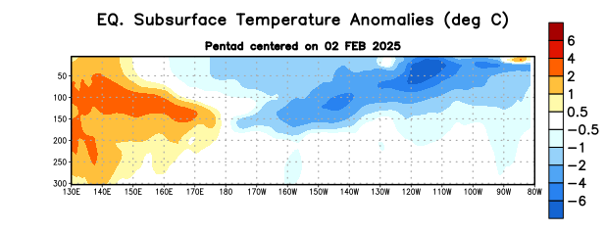
Figure 4. Depth-longitude section of equatorial Pacific upper-ocean (0-300m) temperature anomalies (°C) centered on the pentad of 2 February 2025. Anomalies are departures from the 1991-2020 base period pentad means.

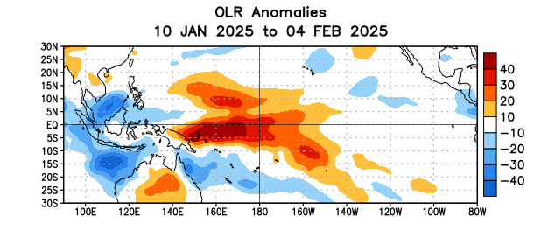
Figure 5. Average outgoing longwave radiation (OLR) anomalies (W/m²) for the period 10 January – 4 February 2025. OLR anomalies are computed as departures from the 1991-2020 base period pentad means.
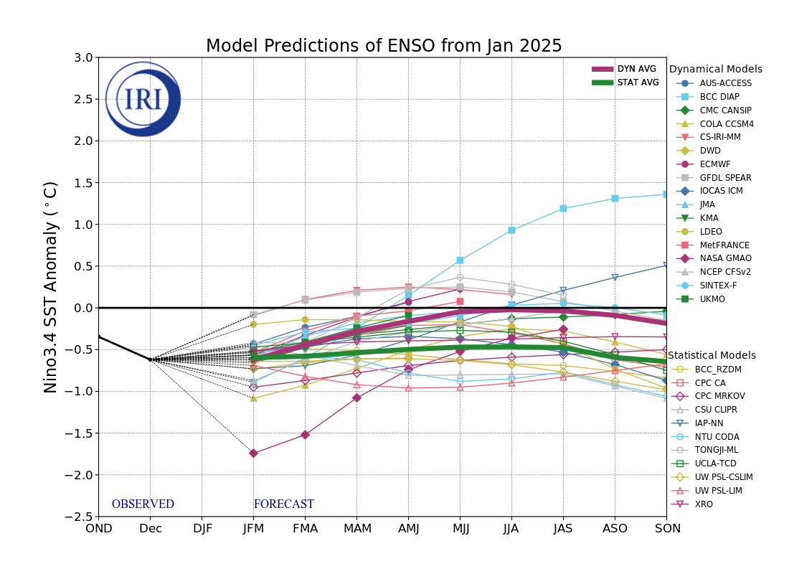
Figure 6. Forecasts of sea surface temperature (SST) anomalies for the Niño 3.4 region (5°N-5°S, 120°W-170°W). Figure updated 21 January 2025 by the International Research Institute (IRI) for Climate and Society.

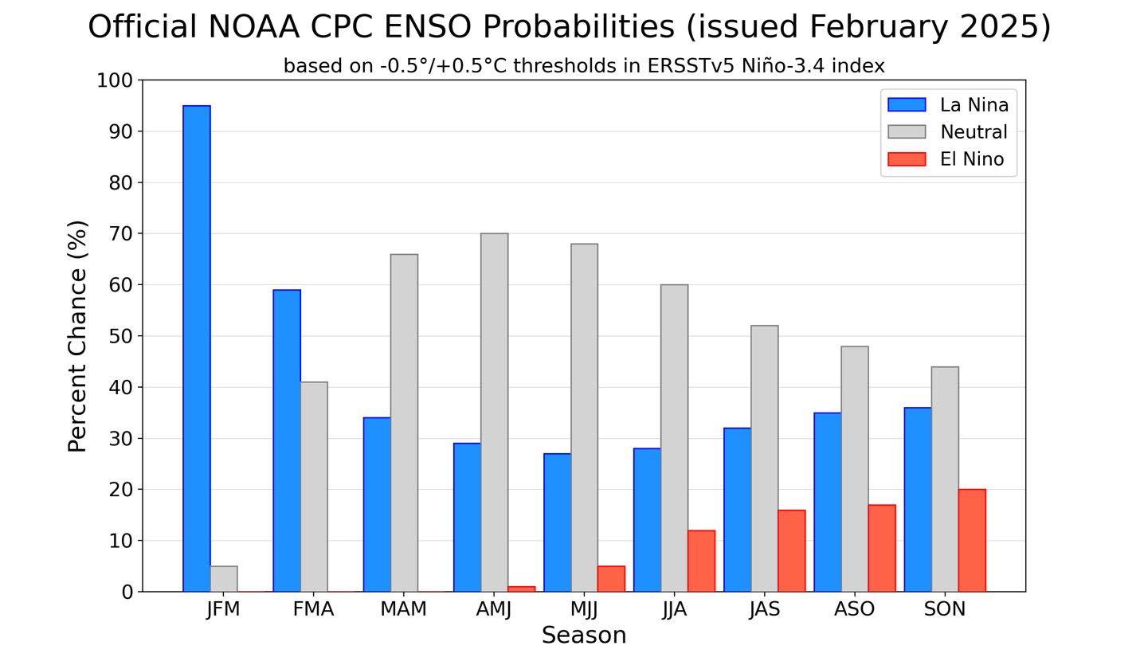
Figure 7. Official ENSO probabilities for the Niño 3.4 sea surface temperature index (5°N-5°S, 120°W-170°W). Figure updated 13 February 2025.

